Laboratory no. 4

שם הסטודנט: ____
ת.ז.: ____

- נא לשלוח למודל – 4 קבצים ,קובץ הוורד , ו3 קבצי סימולציה(לכל חלק קובץ סימולציה) .

Router Configuration and Routing

In Cisco Packet Tracer open file simulation from Laboratory no. 5.

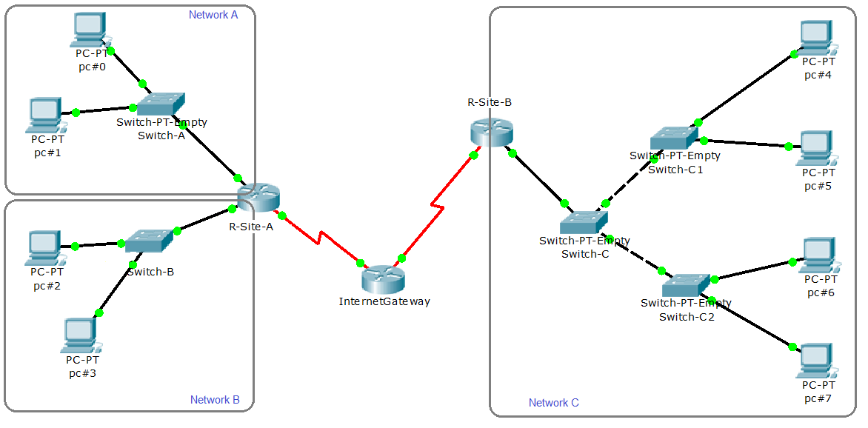

Connection data table
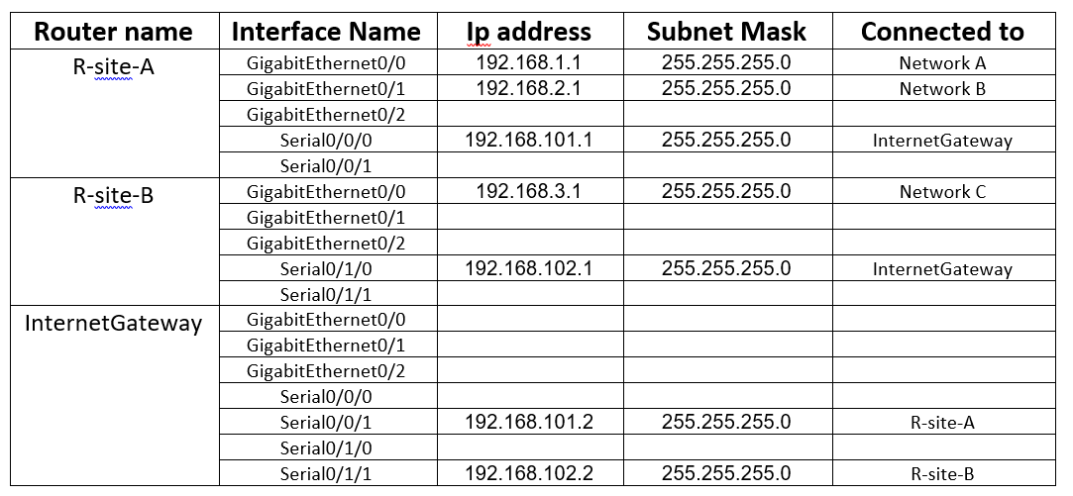

In this lab you will do actual router configuration using the Command Line Interface (CLI).

Part 1:
- Define a static routing on routers. To define a static routing work in Global configuration Mode router(config)#.
Using command: ip route remote_network_ID network_mask gateway_IP
The router "R-Site-A" know how to reach the networks “Network-A” and “Network-B” because those networks connected to router directly. The router “R-Site-A” doesn’t know where the network “Network-C” is and doesn’t know how to reach to the network “Network-C”. To reach “Network-C” router “R-Site-A” you need send packets to interface “Serial 0/0/1” on router “InternetGateway” which transfer those packets to “Network-C” through interface “Serial 0/1/1”. Define router for back path as well.

  - On router “R-Site-A” define static route for the network “Network-C”. In command use IP address where IP is address of neighbor through packets transferred.
Write the commands, with router prompt:
R-Site-A(config)#ip route 192.168.3.0 255.255.255.0 192.168.101.2

  - On router "R-Site-B" define static route for the networks “Network-A”, “Network-B”. In command use network interface name of router instead IP address.
Write the commands, with router prompt:
R-Site-B(config)#ip route 192.168.1.0 255.255.255.0 Serial0/1/0
R-Site-B(config)#ip route 192.168.2.0 255.255.255.0 Serial0/1/0

  - On router "InternetGateway" define static route for the networks “Network-A”, “Network-B” and “Network-C”.
Write the commands, with router prompt:
InternetGateway (config)#ip route 192.168.1.0 255.255.255.0 192.168.101.1
InternetGateway (config)#ip route 192.168.2.0 255.255.255.0 192.168.101.1
InternetGateway (config)#ip route 192.168.3.0 255.255.255.0 192.168.102.1

- Checking routers in your network.
  - On routers “R-Site-A”, “R-Site-B” and "InternetGateway" display the current running configuration, and check the route settings. Use command show running-config, work in Privilege Exec Mode.
Put the commands report here, with router prompt:

R-Site-A:
interface GigabitEthernet0/0
description Network-A
ip address 192.168.1.1 255.255.255.0
duplex auto
speed auto
!
interface GigabitEthernet0/1
description Network-B
ip address 192.168.2.1 255.255.255.0
duplex auto
speed auto
!
interface GigabitEthernet0/2
no ip address
duplex auto
speed auto
shutdown
!
interface Serial0/0/0
ip address 192.168.101.1 255.255.255.0
!
interface Serial0/0/1
no ip address
clock rate 2000000
shutdown
!
interface Vlan1
no ip address
shutdown
!
router rip
!
ip classless
ip route 192.168.3.0 255.255.255.0 192.168.101.2
!
ip flow-export version 9

R-Site-B:
interface GigabitEthernet0/0
description Network-C
ip address 192.168.3.1 255.255.255.0
duplex auto
speed auto
!
interface GigabitEthernet0/1
no ip address
duplex auto
speed auto
shutdown
!
interface GigabitEthernet0/2
no ip address
duplex auto
speed auto
shutdown
!
interface Serial0/1/0
ip address 192.168.102.1 255.255.255.0
!
interface Serial0/1/1
no ip address
clock rate 2000000
shutdown
!
interface Vlan1
no ip address
shutdown
!
ip classless
ip route 192.168.1.0 255.255.255.0 Serial0/1/0
ip route 192.168.2.0 255.255.255.0 Serial0/1/0
!
ip flow-export version 9

InternetGateway:
interface GigabitEthernet0/0
no ip address
duplex auto
speed auto
shutdown
!
interface GigabitEthernet0/1
no ip address
duplex auto
speed auto
shutdown
!
interface GigabitEthernet0/2
no ip address
duplex auto
speed auto
shutdown
!
interface Serial0/0/0
no ip address
clock rate 2000000
shutdown
!
interface Serial0/0/1
ip address 192.168.101.2 255.255.255.0
clock rate 2000000
!
interface Serial0/1/0
no ip address
clock rate 2000000
shutdown
!
interface Serial0/1/1
ip address 192.168.102.2 255.255.255.0
clock rate 2000000
!
interface Vlan1
no ip address
shutdown
!
ip classless
ip route 192.168.1.0 255.255.255.0 192.168.101.1
ip route 192.168.2.0 255.255.255.0 192.168.101.1
ip route 192.168.3.0 255.255.255.0 192.168.102.1
!
ip flow-export version 9

  - On routers “R-Site-A”, “R-Site-B” and "InternetGateway" display the current state of routing table. Use command show ip route, work in Privilege Exec Mode.
Put the commands report, with router prompt:

R-Site-A:
192.168.1.0/24 is variably subnetted, 2 subnets, 2 masks
C 192.168.1.0/24 is directly connected, GigabitEthernet0/0
L 192.168.1.1/32 is directly connected, GigabitEthernet0/0
192.168.2.0/24 is variably subnetted, 2 subnets, 2 masks
C 192.168.2.0/24 is directly connected, GigabitEthernet0/1
L 192.168.2.1/32 is directly connected, GigabitEthernet0/1
S 192.168.3.0/24 [1/0] via 192.168.101.2
192.168.101.0/24 is variably subnetted, 2 subnets, 2 masks
C 192.168.101.0/24 is directly connected, Serial0/0/0
L 192.168.101.1/32 is directly connected, Serial0/0/0

R-Site-B:
S 192.168.1.0/24 is directly connected, Serial0/1/0
S 192.168.2.0/24 is directly connected, Serial0/1/0
192.168.3.0/24 is variably subnetted, 2 subnets, 2 masks
C 192.168.3.0/24 is directly connected, GigabitEthernet0/0
L 192.168.3.1/32 is directly connected, GigabitEthernet0/0
192.168.102.0/24 is variably subnetted, 2 subnets, 2 masks
C 192.168.102.0/24 is directly connected, Serial0/1/0
L 192.168.102.1/32 is directly connected, Serial0/1/0

InternetGateway:
S 192.168.1.0/24 [1/0] via 192.168.101.1
S 192.168.2.0/24 [1/0] via 192.168.101.1
S 192.168.3.0/24 [1/0] via 192.168.102.1
192.168.101.0/24 is variably subnetted, 2 subnets, 2 masks
C 192.168.101.0/24 is directly connected, Serial0/0/1
L 192.168.101.2/32 is directly connected, Serial0/0/1
192.168.102.0/24 is variably subnetted, 2 subnets, 2 masks
C 192.168.102.0/24 is directly connected, Serial0/1/1
L 192.168.102.2/32 is directly connected, Serial0/1/1

  - Make the ping from a computer in network "Network-A" to a computer in network "Network-C". If request is timed out try again, if the second time you receive "Request timed out" check routing table on routers in network, and correct routing definition.
Put the command report here:
From pc with ip 192.168.1.1, ping to pc with ip 192.168.3.10

PC>ping 192.168.3.10

Pinging 192.168.3.10 with 32 bytes of data:

Reply from 192.168.3.10: bytes=32 time=3ms TTL=125
Reply from 192.168.3.10: bytes=32 time=2ms TTL=125
Reply from 192.168.3.10: bytes=32 time=2ms TTL=125
Reply from 192.168.3.10: bytes=32 time=7ms TTL=125

Ping statistics for 192.168.3.10:
Packets: Sent = 4, Received = 4, Lost = 0 (0% loss),
Approximate round trip times in milli-seconds:
Minimum = 2ms, Maximum = 7ms, Average = 3ms

  - Make the ping from a computer in network "Network-C" to a computer in network "Network-B". If request is timed out try again, if the second time you receive "Request timed out" check routing table on routers in network, and correct routing definition.
Put the command report here:
From pc with ip 192.168.3.10, ping to pc with ip 192.168.2.1

PC>ping 192.168.2.1

Pinging 192.168.2.1 with 32 bytes of data:

Reply from 192.168.2.1: bytes=32 time=2ms TTL=253
Reply from 192.168.2.1: bytes=32 time=2ms TTL=253
Reply from 192.168.2.1: bytes=32 time=2ms TTL=253
Reply from 192.168.2.1: bytes=32 time=2ms TTL=253

Ping statistics for 192.168.2.1:
Packets: Sent = 4, Received = 4, Lost = 0 (0% loss),
Approximate round trip times in milli-seconds:
Minimum = 2ms, Maximum = 2ms, Average = 2ms

- Save your simulation on file M205Net-Lab5_Static.pkt.

Part 2:
- Define static routing (with default route) in network. Working in Global configuration Mode router(config)#.
  - On routers “R-Site-A” and “R-Site-B” remove all static routers.
Use command no ip route remoute_network_ID network_mask.
Write the commands, with router prompt:

R-Site-A:
R-Site-A (config)#no ip route 192.168.3.0 255.255.255.0

R-Site-B:
R-Site-B (config)#no ip route 192.168.1.0 255.255.255.0
R-Site-B (config)#no ip route 192.168.2.0 255.255.255.0

  - On routers “R-Site-A” and “R-Site-B” define default route.
Use command ip route 0.0.0.0 0.0.0.0 Serial 0/x/x. Where 0/x/x in number of interface that connected to "InternetGateway" router.
Write the command, with router prompt:

R-Site-A:
R-Site-A (config)#ip route 0.0.0.0 0.0.0.0 Serial0/0/0

R-Site-B:
R-Site-B (config)#ip route 0.0.0.0 0.0.0.0 Serial0/1/0

  - On routers “R-Site-A”, “R-Site-B” and "InternetGateway" display the current state of routing table. Use command show ip route, work in Privilege Exec Mode.
Put the commands report here, with router prompt:

R-Site-A:
Gateway of last resort is 0.0.0.0 to network 0.0.0.0

192.168.1.0/24 is variably subnetted, 2 subnets, 2 masks
C 192.168.1.0/24 is directly connected, GigabitEthernet0/0
L 192.168.1.1/32 is directly connected, GigabitEthernet0/0
192.168.2.0/24 is variably subnetted, 2 subnets, 2 masks
C 192.168.2.0/24 is directly connected, GigabitEthernet0/1
L 192.168.2.1/32 is directly connected, GigabitEthernet0/1
192.168.101.0/24 is variably subnetted, 2 subnets, 2 masks
C 192.168.101.0/24 is directly connected, Serial0/0/0
L 192.168.101.1/32 is directly connected, Serial0/0/0
S* 0.0.0.0/0 is directly connected, Serial0/0/0

R-Site-B:
Gateway of last resort is 0.0.0.0 to network 0.0.0.0

192.168.3.0/24 is variably subnetted, 2 subnets, 2 masks
C 192.168.3.0/24 is directly connected, GigabitEthernet0/0
L 192.168.3.1/32 is directly connected, GigabitEthernet0/0
192.168.102.0/24 is variably subnetted, 2 subnets, 2 masks
C 192.168.102.0/24 is directly connected, Serial0/1/0
L 192.168.102.1/32 is directly connected, Serial0/1/0
S* 0.0.0.0/0 is directly connected, Serial0/1/0
  - Make ping from a computer in network "Network-A" to a computer in network "Network-C" and from a computer in network "Network-C" to a computer in network "Network-B". If request is timed out try again, if the second time you receive "Request timed out" check routing table on routers in network, and correct routing definition.
Put the commands report here:

From pc with ip 192.168.3.10, ping to pc with ip 192.168.2.1

PC>ping 192.168.2.1

Pinging 192.168.2.1 with 32 bytes of data:

Reply from 192.168.2.1: bytes=32 time=1ms TTL=255
Reply from 192.168.2.1: bytes=32 time=0ms TTL=255
Reply from 192.168.2.1: bytes=32 time=0ms TTL=255
Reply from 192.168.2.1: bytes=32 time=0ms TTL=255

Ping statistics for 192.168.2.1:
Packets: Sent = 4, Received = 4, Lost = 0 (0% loss),
Approximate round trip times in milli-seconds:
Minimum = 0ms, Maximum = 1ms, Average = 0ms

From pc with ip 192.168.1.1, ping to pc with ip 192.168.3.10

PC>ping 192.168.3.10

Pinging 192.168.3.10 with 32 bytes of data:

Reply from 192.168.3.10: bytes=32 time=4ms TTL=128
Reply from 192.168.3.10: bytes=32 time=3ms TTL=128
Reply from 192.168.3.10: bytes=32 time=1ms TTL=128
Reply from 192.168.3.10: bytes=32 time=5ms TTL=128

Ping statistics for 192.168.3.10:
Packets: Sent = 4, Received = 4, Lost = 0 (0% loss),
Approximate round trip times in milli-seconds:
Minimum = 1ms, Maximum = 5ms, Average = 3ms

- Save your simulation on file M205Net-Lab5_Default.pkt.

Part 3:
- Define dynamic routing. Working in Routing Engine Configuration Mode router(config-router)#.
  - On routers “R-Site-A”, “R-Site-B” and "InternetGateway" remove all static routers. Use the command no ip route remote_network_ID network_mask.
Write the commands, with router prompt:

R-Site-A:
R-Site-A (config)#no ip route 0.0.0.0 0.0.0.0

R-Site-B:
R-Site-B (config)#no ip route 0.0.0.0 0.0.0.0

InternetGateway:
InternetGateway (config)#no ip route 192.168.1.0 255.255.255.0
InternetGateway (config)#no ip route 192.168.2.0 255.255.255.0
InternetGateway (config)#no ip route 192.168.3.0 255.255.255.0

  - On routers “R-Site-A”, “R-Site-B” and "InternetGateway" enter to the Routing Engine Configuration Mode (use the command router(config)#router rip from Global Configuration Mode) for the Routing Information Protocol (RIP). Specify network for the RIP routing process, use only network that connected to router. Use command network connected_network_ID.
Write the commands, with router prompt:

R-Site-A:
R-Site-A(config)#router rip
R-Site-A(config-router)#network 192.168.1.0
R-Site-B(config-router)#network 192.168.2.0
R-Site-B(config-router)#network 192.168.101.0

R-Site-B:
R-Site-B(config)#router rip
R-Site-B(config-router)#network 192.168.3.0
R-Site-B(config-router)#network 192.168.102.0

InternetGateway:
InternetGateway(config)#router rip
InternetGateway(config-router)#network 192.168.101.0
InternetGateway(config-router)#network 192.168.102.0

  - On routers “R-Site-A”, “R-Site-B” and "InternetGateway" display the current running configuration, and check the route settings. Use command show running-config, work in Privilege Exec Mode.
Put the commands report here, with router prompt:

R-Site-A:
interface GigabitEthernet0/0
description Network-A
ip address 192.168.1.1 255.255.255.0
duplex auto
speed auto
!
interface GigabitEthernet0/1
description Network-B
ip address 192.168.2.1 255.255.255.0
duplex auto
speed auto
!
interface GigabitEthernet0/2
no ip address
duplex auto
speed auto
shutdown
!
interface Serial0/0/0
ip address 192.168.101.1 255.255.255.0
!
interface Serial0/0/1
no ip address
clock rate 2000000
shutdown
!
interface Vlan1
no ip address
shutdown
!
router rip
network 192.168.1.0
network 192.168.2.0
network 192.168.101.0
!
ip classless
!
ip flow-export version 9

R-Site-B:
interface GigabitEthernet0/0
description Network-C
ip address 192.168.3.1 255.255.255.0
duplex auto
speed auto
!
interface GigabitEthernet0/1
no ip address
duplex auto
speed auto
shutdown
!
interface GigabitEthernet0/2
no ip address
duplex auto
speed auto
shutdown
!
interface Serial0/1/0
ip address 192.168.102.1 255.255.255.0
!
interface Serial0/1/1
no ip address
clock rate 2000000
shutdown
!
interface Vlan1
no ip address
shutdown
!
router rip
network 192.168.3.0
network 192.168.102.0
!
ip classless
!
ip flow-export version 9

EthernetGateway:
interface GigabitEthernet0/0
no ip address
duplex auto
speed auto
shutdown
!
interface GigabitEthernet0/1
no ip address
duplex auto
speed auto
shutdown
!
interface GigabitEthernet0/2
no ip address
duplex auto
speed auto
shutdown
!
interface Serial0/0/0
no ip address
clock rate 2000000
shutdown
!
interface Serial0/0/1
ip address 192.168.101.2 255.255.255.0
clock rate 2000000
!
interface Serial0/1/0
no ip address
clock rate 2000000
shutdown
!
interface Serial0/1/1
ip address 192.168.102.2 255.255.255.0
clock rate 2000000
!
interface Vlan1
no ip address
shutdown
!
router rip
network 192.168.101.0
network 192.168.102.0
!
ip classless
!
ip flow-export version 9

  - On routers “R-Site-A”, “R-Site-B” and "InternetGateway" display the current state of routing table. Use command show ip route, work in Privilege Exec Mode.
Put the commands report here:

R-Site-A:
Gateway of last resort is not set

192.168.1.0/24 is variably subnetted, 2 subnets, 2 masks
C 192.168.1.0/24 is directly connected, GigabitEthernet0/0
L 192.168.1.1/32 is directly connected, GigabitEthernet0/0
192.168.2.0/24 is variably subnetted, 2 subnets, 2 masks
C 192.168.2.0/24 is directly connected, GigabitEthernet0/1
L 192.168.2.1/32 is directly connected, GigabitEthernet0/1
R 192.168.3.0/24 [120/2] via 192.168.101.2, 00:00:06, Serial0/0/0
192.168.101.0/24 is variably subnetted, 2 subnets, 2 masks
C 192.168.101.0/24 is directly connected, Serial0/0/0
L 192.168.101.1/32 is directly connected, Serial0/0/0
R 192.168.102.0/24 [120/1] via 192.168.101.2, 00:00:06, Serial0/0/0

R-Site-B:
Gateway of last resort is not set

R 192.168.1.0/24 [120/2] via 192.168.102.2, 00:00:21, Serial0/1/0
R 192.168.2.0/24 [120/2] via 192.168.102.2, 00:00:21, Serial0/1/0
192.168.3.0/24 is variably subnetted, 2 subnets, 2 masks
C 192.168.3.0/24 is directly connected, GigabitEthernet0/0
L 192.168.3.1/32 is directly connected, GigabitEthernet0/0
R 192.168.101.0/24 [120/1] via 192.168.102.2, 00:00:21, Serial0/1/0
192.168.102.0/24 is variably subnetted, 2 subnets, 2 masks
C 192.168.102.0/24 is directly connected, Serial0/1/0
L 192.168.102.1/32 is directly connected, Serial0/1/0

InternetGateway:
Gateway of last resort is not set

R 192.168.1.0/24 [120/1] via 192.168.101.1, 00:00:26, Serial0/0/1
R 192.168.2.0/24 [120/1] via 192.168.101.1, 00:00:26, Serial0/0/1
R 192.168.3.0/24 [120/1] via 192.168.102.1, 00:00:14, Serial0/1/1
192.168.101.0/24 is variably subnetted, 2 subnets, 2 masks
C 192.168.101.0/24 is directly connected, Serial0/0/1
L 192.168.101.2/32 is directly connected, Serial0/0/1
192.168.102.0/24 is variably subnetted, 2 subnets, 2 masks
C 192.168.102.0/24 is directly connected, Serial0/1/1
L 192.168.102.2/32 is directly connected, Serial0/1/1

  - Make ping from a computer in network "Network-A" to a computer in network "Network-C" and from a computer in network "Network-C" to a computer in network "Network-B". If request is timed out try again, if the second time you receive "Request timed out" check routing table on routers in network, and correct routing definition.
Put the commands report here:

From pc with ip 192.168.3.10, ping to pc with ip 192.168.2.1

C:\>ping 192.168.2.1

Pinging 192.168.2.1 with 32 bytes of data:

Reply from 192.168.2.1: bytes=32 time<1ms TTL=255
Reply from 192.168.2.1: bytes=32 time<1ms TTL=255
Reply from 192.168.2.1: bytes=32 time<1ms TTL=255
Reply from 192.168.2.1: bytes=32 time<1ms TTL=255

Ping statistics for 192.168.2.1:
Packets: Sent = 4, Received = 4, Lost = 0 (0% loss),
Approximate round trip times in milli-seconds:
Minimum = 0ms, Maximum = 0ms, Average = 0ms

From pc with ip 192.168.1.1, ping to pc with ip 192.168.3.10

C:\>ping 192.168.3.10

Pinging 192.168.3.10 with 32 bytes of data:

Reply from 192.168.3.10: bytes=32 time=4ms TTL=128
Reply from 192.168.3.10: bytes=32 time=6ms TTL=128
Reply from 192.168.3.10: bytes=32 time=2ms TTL=128
Reply from 192.168.3.10: bytes=32 time=6ms TTL=128

Ping statistics for 192.168.3.10:
Packets: Sent = 4, Received = 4, Lost = 0 (0% loss),
Approximate round trip times in milli-seconds:
Minimum = 2ms, Maximum = 6ms, Average = 4ms

- Save your simulation on file M205Net-Lab5_DinamicRIP.pkt.
- Save file and send four files (word and three simulations).

